**NITTE MEENAKSHI INSTITUTE OF TECHNOLOGY**

**KARNATAKA**



**REPORT ON WEB PROJECT**

**“TRAVEL TRENDS”**

**A USER FRIENDLY TOURS & TRAVELS WEBSITE**

**Submitted by**

JALPA C.J - 1NT19CS088

K.M BHOOMIKA - 1NT19CS091

31 - JULY - 2021

**Under the guidance of Prof. UMA R**

Department of Computer Science and Engineering

# DEPT. OF COMPUTER SCIENCE & ENGINEERING

***Certificate***

This is to certify that the Mini WEB Project Report entitled, **“TRAVEL TRENDS”,** prepared by *JALPA C.J* (1NT19CS088) and *K.M BHOOMIKA* (1NT19CS0091) are bonafide students of Nitte Meenakshi Institute of Technology in partial fulfilment of the requirements for the award of **Bachelor of Technology in Computer Science and Engineering** of the Visvesvaraya Technological University, Belagavi -590018 during the academic year 2020-21.

It is certified that all the corrections and suggestions indicated for Internal Assessment have been incorporated in the report deposited in the departmental library. The mini web project report has been approved as it satisfies the academic requirements prescribed for the said degree.

**----------------------- ----------------------**

**Signature of Guide Signature of HOD**

**Name: Prof. UMA R Dr. THIPESWAMY**

**Designation: Assoc. Professor Assoc. Professor& HOD**

**Dept. of CSE, NMIT** **Dept. of CSE, NMIT**

# CONTENTS

|  |  |
| --- | --- |
| **1** | ACKNOWLEDGEMENT |
| **2** | INTRODUCTION |
| **3** | HARDWARE / SOFTWARE |
| **4** | DESIGN |
| **5** | IMPLEMENTATION |
| **6** | CONCLUSION |
| **7** | REFERENCE |

**ACKNOWLEDGEMENT**

We would like to express our heartfelt gratitude to Ms. Uma R for giving us the opportunity to work under their guidance and help us gain immensely enriching professional experience.

We thank **Prof. / Dr Thippeswamy** (HOD computer science department) for his ongoing support and encouragement in every aspect.

I consider it a privilege and honor to express my gratitude towards my guide **Prof. Uma R**, department of Computer Science & Engineering, for her valuable guidance throughout the tenure of this review.

Last but not the least, entire staff of Department of Computer Engineering for guiding our thoughts and vision.

The successful completion of our project would not have been possible without the dedicated support from all our mentors, family, and friends.

# INTRODUCTION

# 

A travel website is a website that is dedicated to travel. The site may be focused on travel reviews, trip fares, or a combination of both. Over 1.5 billion people book travel per year, 70% of which is done online.

Categories of travel websites include:

• Travelogues/Blogs

• Service providers - Individual airlines, hotels, bed and breakfasts, cruise lines, automobile rental companies, and other travel-related service providers often maintain their own web sites providing retail sales. Many with complex offerings include some sort of search engine technology to look for bookings within a certain timeframe, service class, geographic location, or price range.

• Online travel agencies

• Fare aggregators and metasearch engines - Metasearch engines conduct searches across multiple independent search engines. Metasearch engines often make use of "screen scraping" to get live availability of flights. Screen scraping is a way of crawling through the airline websites, getting content from those sites by extracting data from the same HTML feed used by consumers for browsing (rather than using a Semantic Web or database feed designed to be machine-readable). Metasearch engines usually process incoming data to eliminate duplicate entries but may not expose "advanced search" options in the underlying databases (because not all databases support the same options).

• Blogs/News sites on current travel discounts - Travel bargain websites collect and publish bargain rates by advising consumers where to find them online (sometimes but not always through a direct link). Rather than providing detailed search tools, these sites generally focus on offering advertised specials, such as last-minute sales from travel suppliers eager to deplete unused inventory; therefore, these sites often work best for consumers who are flexible about destinations and other key itinerary components.

• Travel and tourism guides - Many websites take the form of a digital version of a traditional guidebook, aiming to provide advice on which destinations, attractions, accommodations, and so on, are worth a visit and providing information on how to access them. Most states, provinces and countries have their own convention and visitor bureaus, which usually sponsor a website dedicated to promoting tourism in their respective regions.

• Social travel website - A social travel website is a type of travel website that will look at where the user is going and pair them with other places they want to go based on where other people have gone.

• Homestays - There are several travel websites that specialize in organizing homestays.

**NEED OF TRAVEL WEBSITE**

Before, any travel agency was able to work entirely offline. Currently, with the development of high technological trends, no tour agency can have a single success without an online presence. Today almost every business is eager to be present in the digital platform. Online presence provides credibility for your company. Nowadays, people are tired of researching. If one needs any product or service, they just search on the internet. If the company has a website, they go on in uncovering whether the service is good enough. Your website is the face of your business in the digital world. It helps your visitors to save their time and energy.

A website gives you a chance to personalize your brand and introduce yourself to the audience in the way you prefer. You don’t share your services, and any information travellers want to get on various platforms or social media. You have an entire portal where everything is about your brand and services.

No matter small or larger agencies, tour management is a difficult process. However, due to our booking management system, you get a chance to control your bookings. The online booking section allows your users to book online in advance.

Best travel agency websites are a great source of information for travellers. Your trustworthy content may be a prompting point for your travel agency web site visitors. The most significant advantage of a travel website is that it gives you a chance to present tour packages and sell them from your own platform.

**HARDWARE/SOFTWARE REQUIREMENTS**

**HARDWARE:-**

* Silverlight 1.1/2 plug-in installed.
* The PC is connected to internet.
* 128/256/512 gb ram.
* 1024 x 768 monitors resolution with 24-bit color.
* Graphics processor that is DirectX 9-capable**.**



It is a reliable connection-oriented protocol that allows byte streaming originating on one

machine to be delivered without any error on any other machine in the network. It fragments the incoming byte stream into discrete messages and parses each one on to the internet layer. At the destination, the receiving TCP process reassembles received messages into the output stream.

TCP also handles the flow control to make sure a fast sender cannot swamp a slow receiver with more messages than it can handle.

**SOFTWARE:-**

## HTML: -

Hypertext Markup Language (HTML) is the standard markup language for creating web pages and web applications. With Cascading Style Sheets (CSS) and JavaScript, it forms a triad of corner stone technologies for the World Wide Web.

HTML elements are the building blocks of HTML pages. With HTML constructs, images and other objects such as interactive forms may be embedded into the rendered page. HTML provides a means to create structured documents by denoting structural semantics for text such as headings, paragraphs, lists, links, quotes and other items.

## CSS: -

CSS is designed to enable the separation of presentation and content, including layout, colors, and fonts. This separation can improve content accessibility, provide more flexibility and control in the specification of presentation characteristics, enable multiple web pages to share formatting by specifying the relevant CSS in a separate CSS file, and reduce complexity and repetition in the structural content.

## JAVASCRIPT: -

JavaScriptoften abbreviated as **JS**, is a programming language that conforms to the ECMAScript specification. JavaScript is high-level, often just-in-time compiled, and multi-paradigm. It has curly-bracket syntax, dynamic typing, prototype-based objectorientation, and first-class functions.

Alongside HTML and CSS, JavaScript is one of the core technologies of the World Wide Web. Over 97% of websites use it client-side for web page behaviour,[]](https://en.wikipedia.org/wiki/JavaScript#cite_note-deployedstats-11) often incorporating thirdparty libraries. All major web browsers have a dedicated JavaScript engine to execute the code on the user's device.

As a multi-paradigm language, JavaScript supports eventdriven, functional, and imperative programming styles. It has application programming interfaces (APIs) for working with text, dates, regular expressions, standard data structures, and the Document Object Model (DOM).

The ECMAScript standard does not include any input/output (I/O), such as networking, storage, or graphics facilities. In practice, the web browser or other runtime system provides JavaScript APIs for I/O.

JavaScript engines were originally used only in web browsers, but they are now core components of other software systems, most notably servers and a variety of applications.

Although there are similarities between JavaScript and Java, including language name, syntax, and respective standard libraries, the two languages are distinct and differ greatly in design.

### BOOTSTRAP: -

Bootstrap is a free and open-source CSS framework directed at responsive, mobile-first front-end web development. It contains CSS- and (optionally) JavaScript-based design templates for typography, forms, buttons, navigation, and other interface components.

Bootstrap is a potent front-end framework used to create modern websites and web apps. It's open-source and free to use, yet features numerous HTML and CSS templates for UI interface elements such as buttons and forms. Bootstrap also supports JavaScript extensions.

### JQUERY: -

jQuery is a lightweight, "write less, do more", JavaScript library. The purpose of jQuery is to make it much easier to use JavaScript onyour website. jQuery takes a lot of common tasks that require many lines of JavaScript code to accomplish and wraps them into methods that you can call with a single line of code.

### PHP: -

PHP is a server-side scripting language that is embedded in HTML. It is used to manage dynamic content, databases, session tracking, even build entire e-commerce sites. It is integrated with several popular databases, including MySQL, PostgreSQL, Oracle, Sybase, Informix, and Microsoft SQL Server.

### MYSQL: -

MySQL is a relational database management system based on SQL – Structured Query Language. The application is used for a wide range of purposes, including data warehousing, e-commerce, and logging applications. The most common use for mySQL however, is for the purpose of a web database.

**AJAX: -**

Ajax (short for "Asynchronous JavaScript and XML") is a set of web development techniques using many web technologies on the client-side to create asynchronous web applications. With Ajax, web applications can send and retrieve data from a server asynchronously (in the background) without interfering with the display and behaviour of the existing page. By decoupling the data interchange layer from the presentation layer, Ajax allows web pages and, by extension, web applications, to change content dynamically without the need to reload the entire page

**IMPLEMENTATION**

The main objective of developing this project was to create a static website for the travel, from which user can get the details of the tour and travel, services, package, and booking. Our Responsive Travel Trends Site is created using HTML5, CSS, JavaScript, jQuery, Bootstrap, Ajax and php. This travel site is quite easy and simple to use and understand.

In this website first if the user who intends to have access to the home page but ends up inputting a mail-id which is not registered or a wrong mail-id or password, the system displays an alert message showing “no user exists” so the user must enter all the details in sign-up page before redirecting to the home page. After the successful user registration, the system returns a message to user saying, “Registration successful, proceed to login”. This information is stored in database and in turn this information is used by the user to login to the homepage.

In the main page, there are basically three sections-Our Services, Our Gallery and Contact Us. The website also has the About Us page, where the user can know more about our travel site. Our Services section consists of three services, they are-Beach, Mountains and Fantasy.

If the user wants to enjoy any service can just click on “Book Now”

And it will be redirected to the Booking page, where the user can know about the various tour packages and has a choice of making reservations online and can check the flight date and can manage more activity .Next Step is payment ,which redirects to payment page where the user can enter the respective card details and the amount to be paid, after the process is over the user gets the message showing “Booked Successfully” .The Booking table in the database holds all the information about the user requesting for reservation on a particular tourism centre.

The Homepage also has Our Gallery section which consists wonderful pictures of Exotic beaches, thrilling adventure sports, lush green peaceful country-side landscapes, ski trips over snow-capped mountains are some the fantasies that lure our users.

The website also includes user-friendly option i.e., Contact Us section, where the user can reach out to the admin if he/she has any suggestions or queries about the tourism product or information by filling out the form.

SCREENSHOTS

SIGN UP PAGE: -

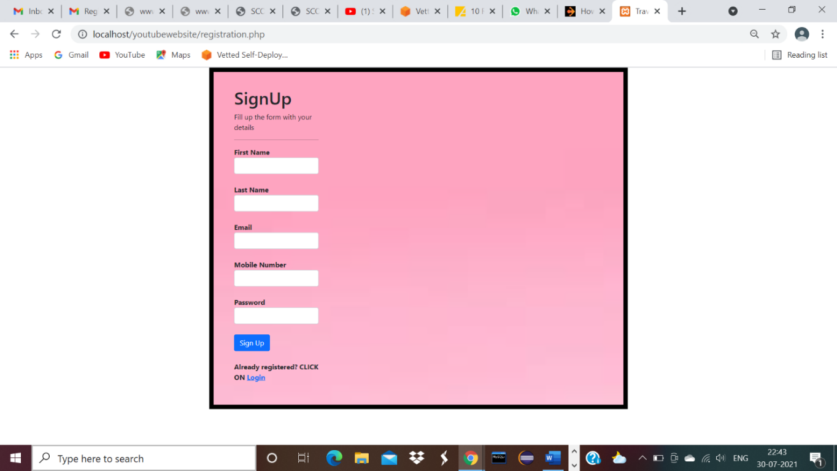

SIGN UP SUCCESSFUL PAGE: -

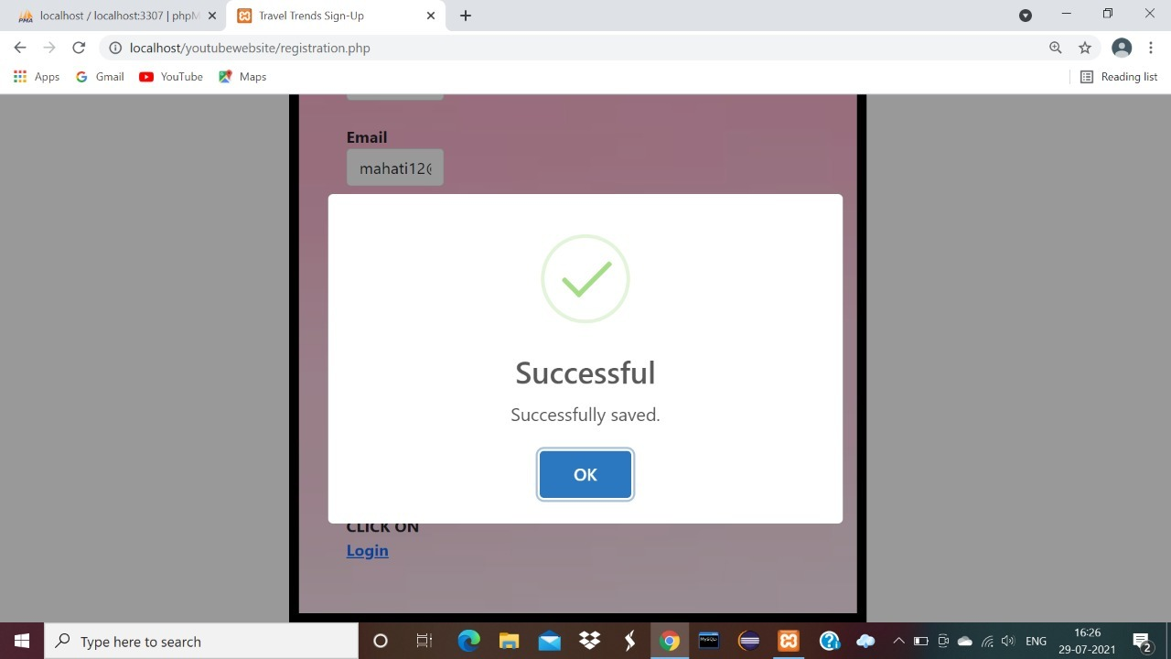

LOGIN PAGE: -

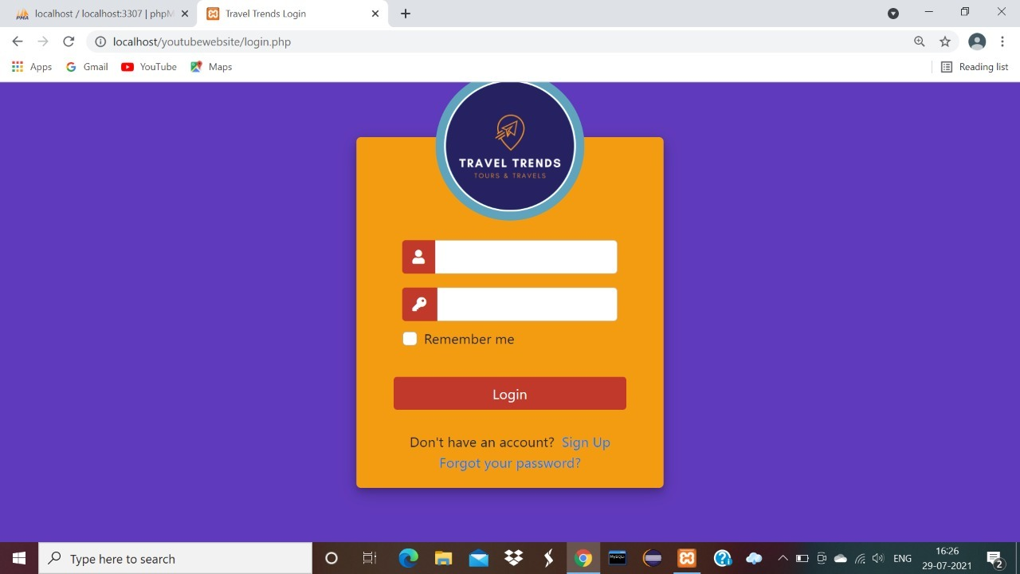

HOME PAGE: -

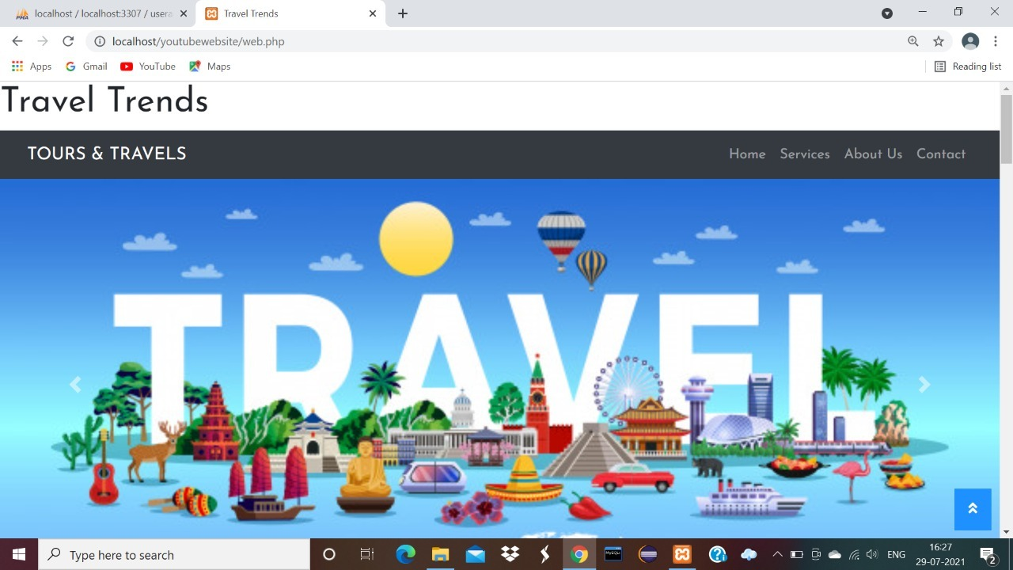

OUR SERVICES: -

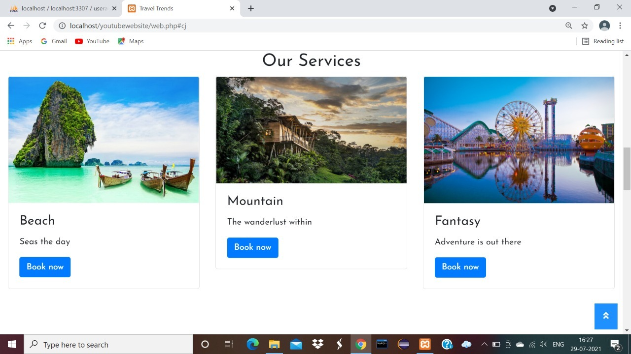

ABOUT US: -

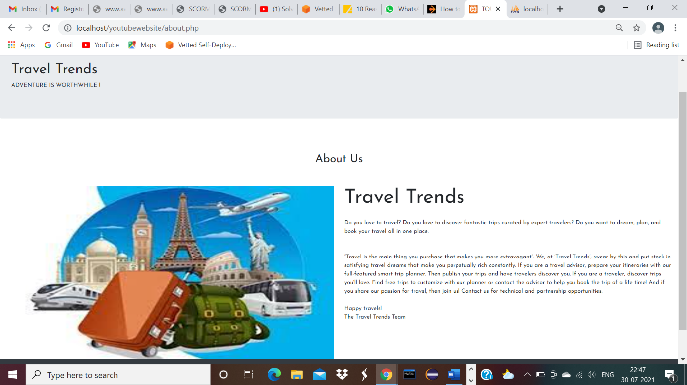

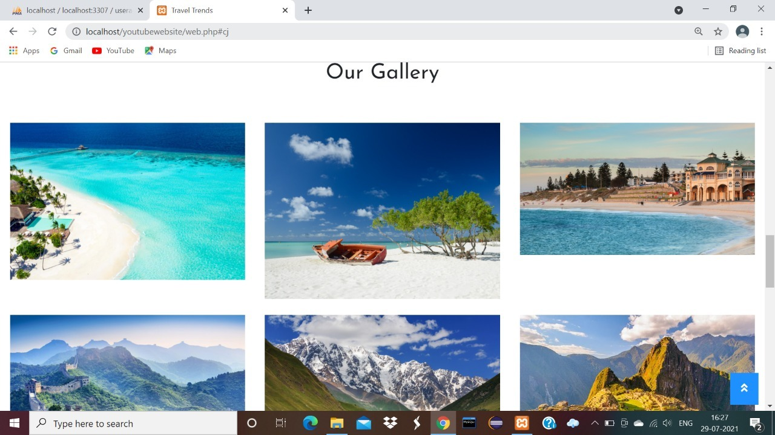

CONTACT US PAGE: -

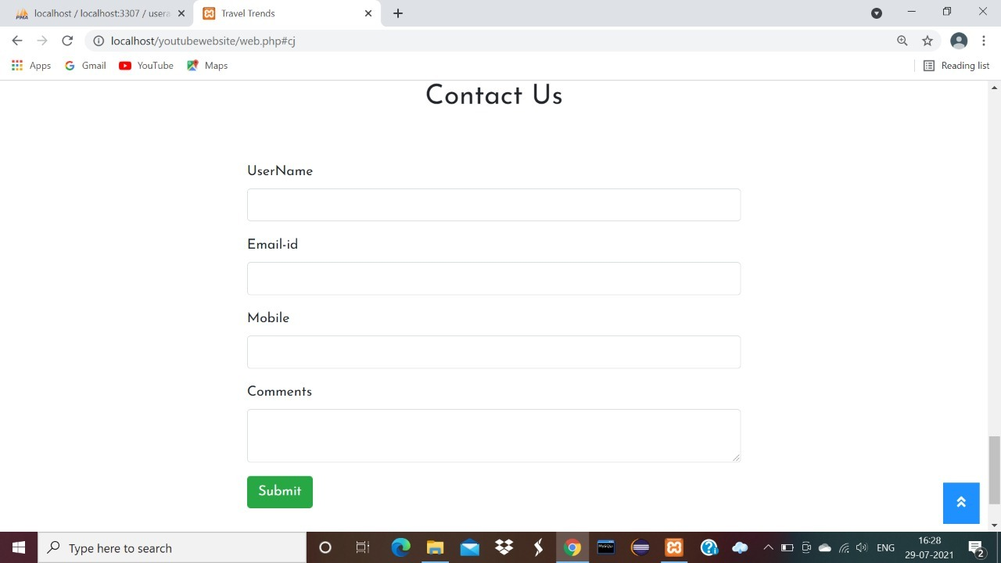

BOOK NOW PAGE: **-**

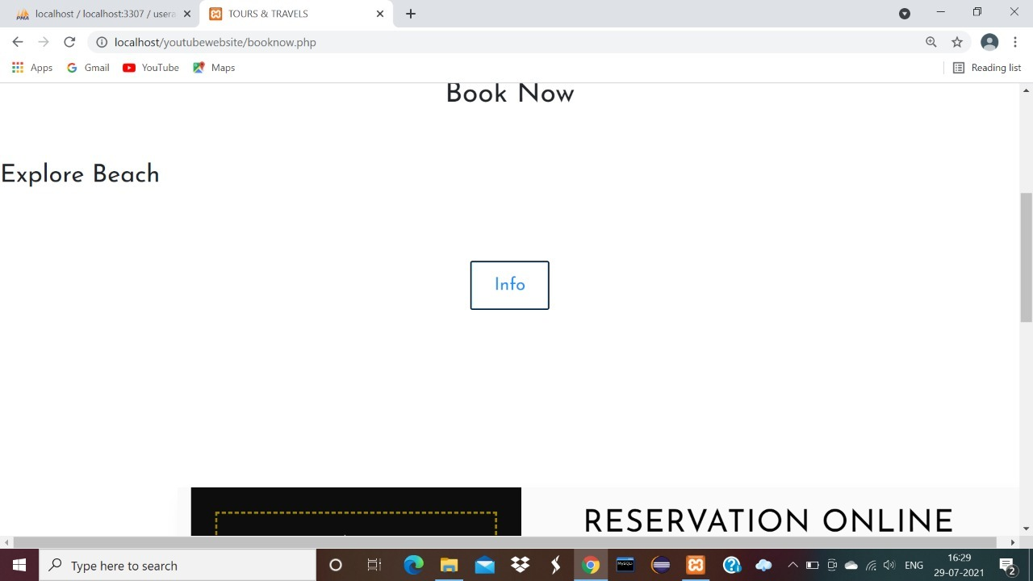

INFO SECTION: -

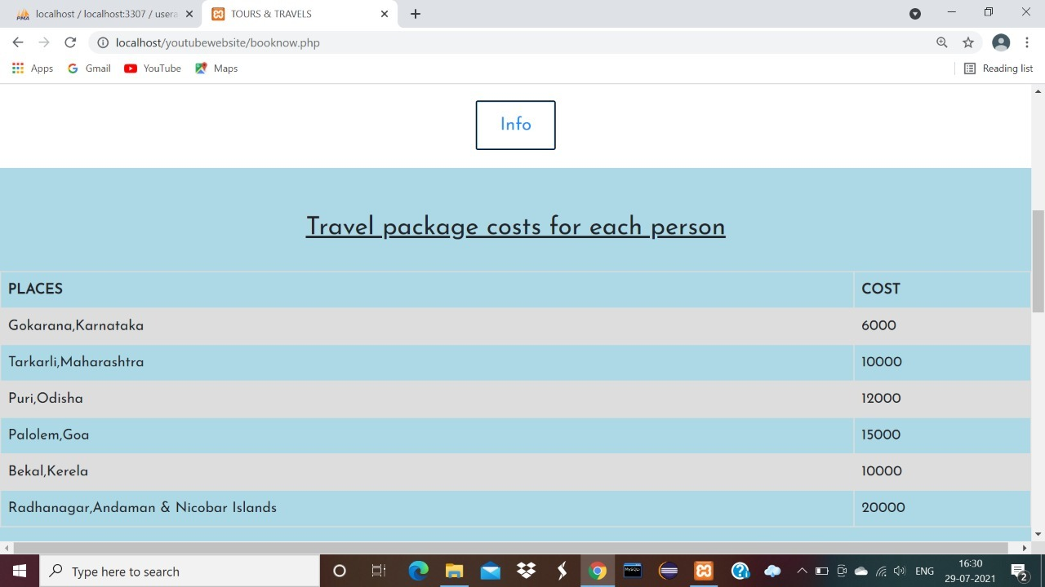

RESERVATION: -

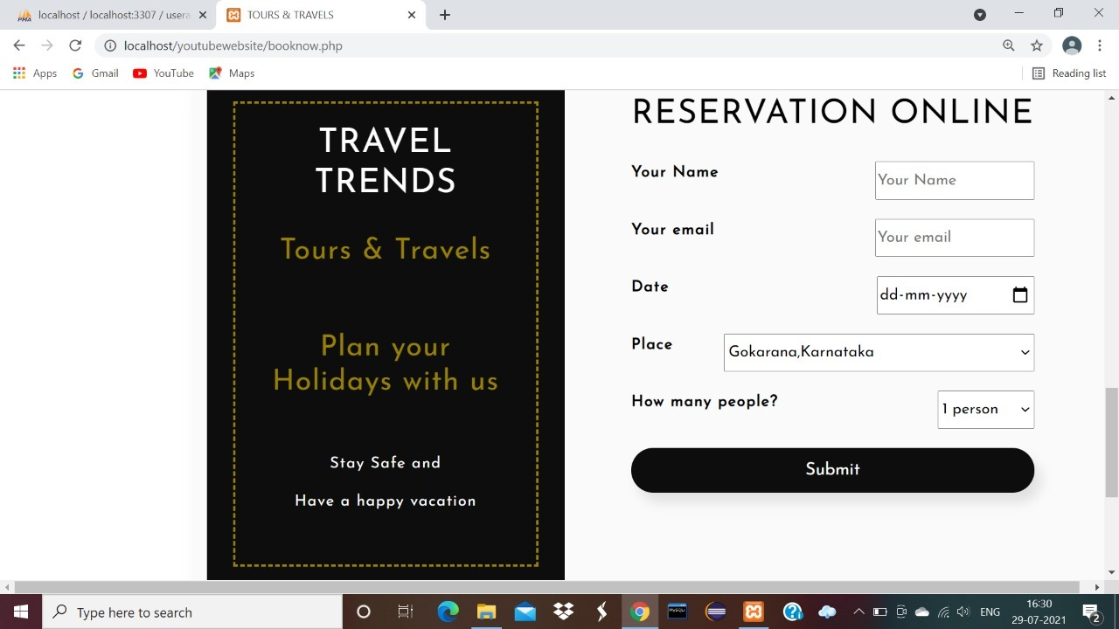

AFTER SUBMISSION: -

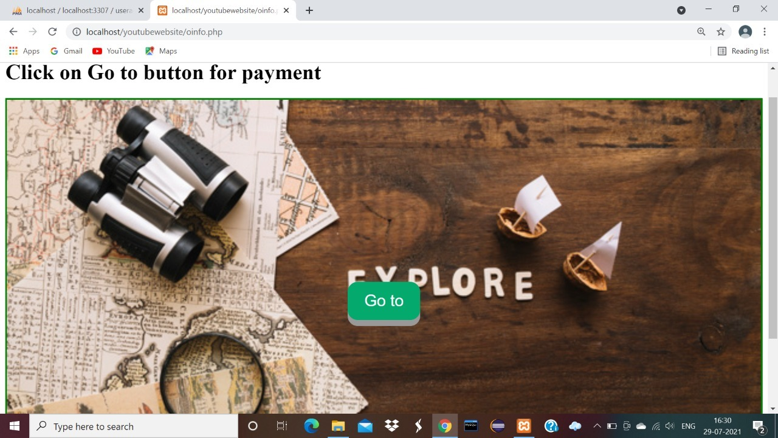

PAYMENT PAGE: -

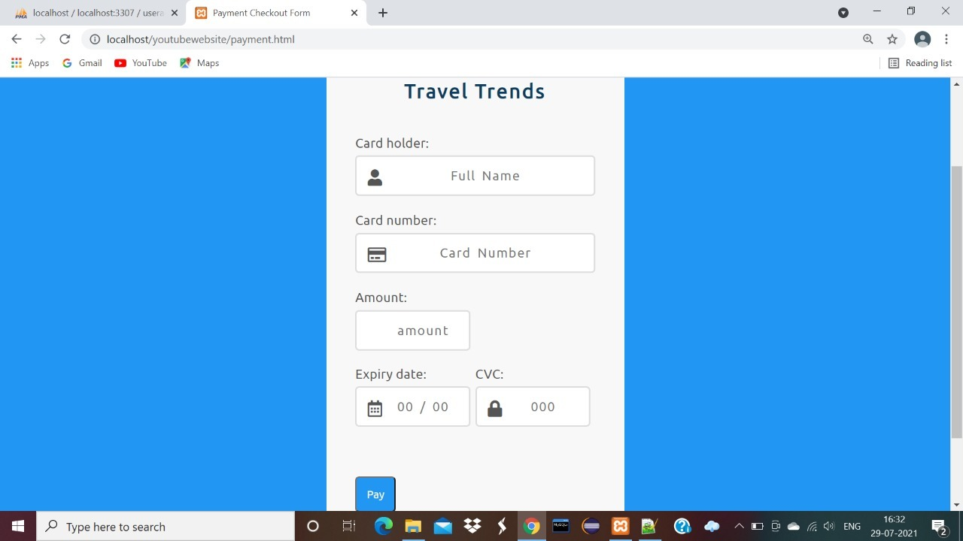



**Proposed Methodology**



Data collection and preparation

Feature selection

Algorithm Choice

Build a model

Testing a model

Extracting the

training data

Train Models

Passive Aggressive

algorithm

Test on holdout set

Test

-

Train split

Generate TFIDF

Results and pickled

models

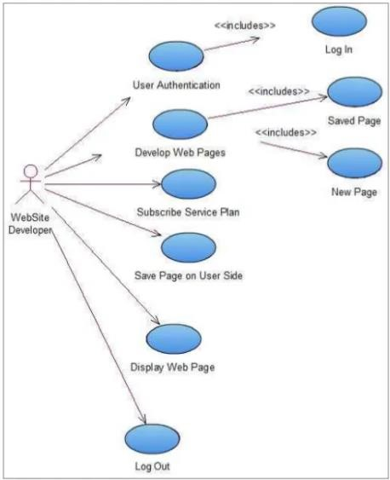

**SOFTWARE QUALITY ATTRIBUTES: -**

There are various software quality attributes that are taken into consideration –

1. **Availability** as TRAVEL TRENDS is a web-based service provided to the users, it will be available as long as server is up.
2. **Interoperability** TRAVEL TRENDS is interoperable on various operating systems, thus increasing the applications usability and flexibility.
3. **Maintainability** TRAVEL TRENDS is a SaaS based service. Hence, all the updates are centralized making the maintenance convenient.
4. **Usability** - The main purpose of developing this TRAVEL TRENDS is to enable the users who

wish to develop their web pages online and who aren't well versed with the technical aspects of coding on standalone applications like Dreamweaver, MS front page etc.

1. **Creative** - Users can apply their imagination in full extent thus enhancing their creative power without actually worrying much about the technical details.

# CONCLUSION

The purpose and objective of TRAVEL TRENDS project is achieved. By providing extremely rich graphical user interface, web page designing is easy and in an aesthetic form.

Flexibility in designing makes user explore their imagination and thus, even a novice user can dream and accomplish their wish of web page designing.

# REFERENCES

For HTTP we referred: -<https://www.w3schools.com/html/>

For CSS we referred: -<https://www.w3schools.com/css/default.asp>

For JavaScript we referred: -<https://www.w3schools.com/js/default.asp>

For SQL we referred: -<https://www.w3schools.com/sql/default.asp>

For PHP we referred: -<https://www.w3schools.com/php/default.asp>

For BOOTSTRAP we referred: -

<https://www.w3schools.com/bootstrap/bootstrap_ver.asp>For jQuery we referred: -

<https://www.w3schools.com/jquery/default.asp>